CS-340-T5534 Client/Server Development 23EW5

2-1 Assignment: CRUD in MongoDB

Jacob Simmons, 12 May 2023

* Load Dataset using import utility

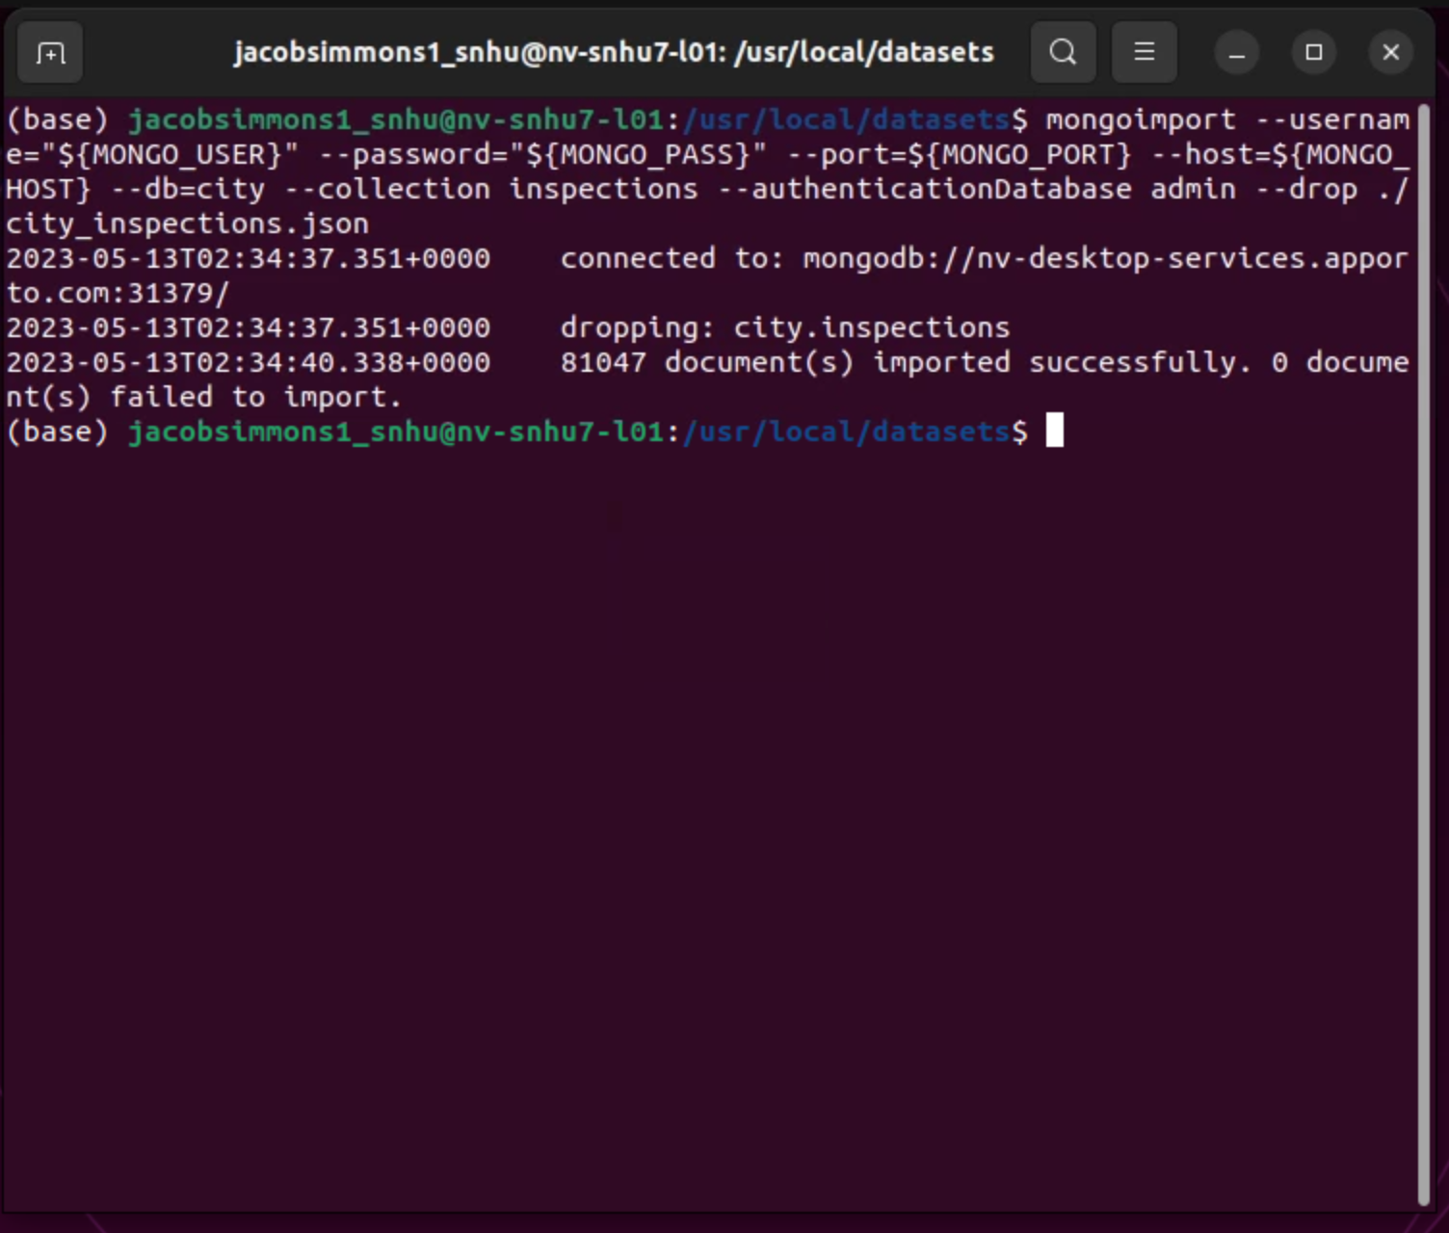

* **Load Verification** 
  1. First will be shown both the database load verification with the username included and then the separate load verifications will be individually highlighted

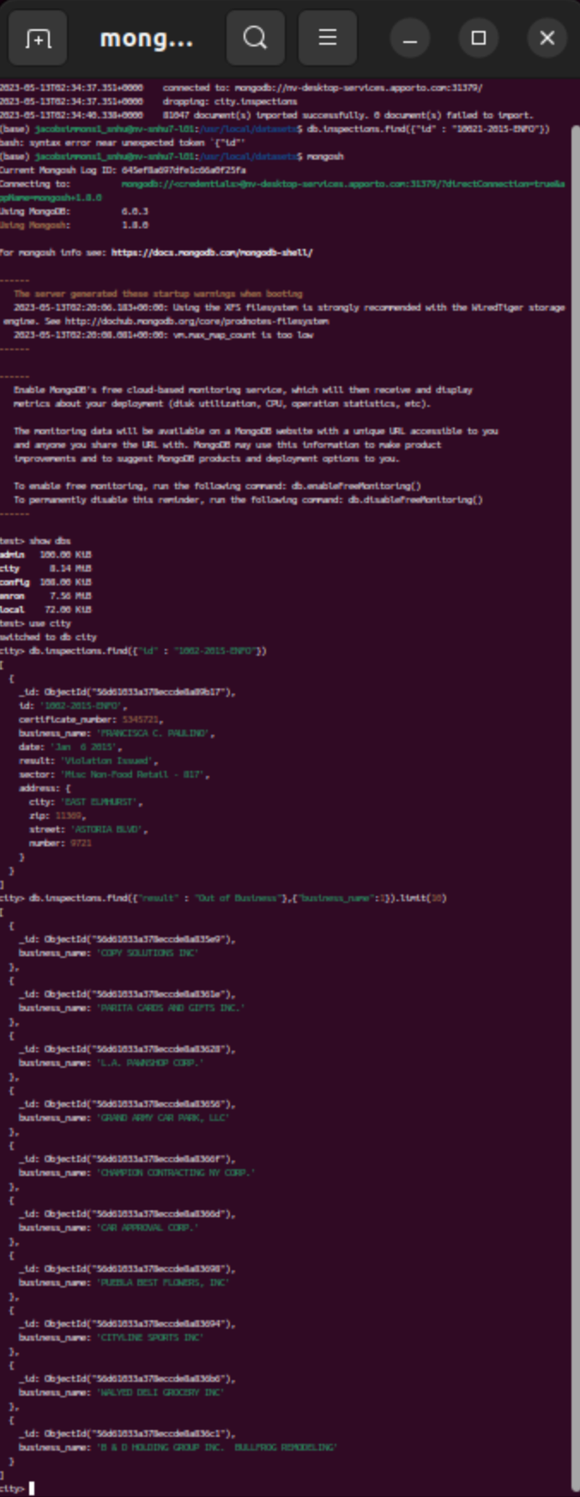

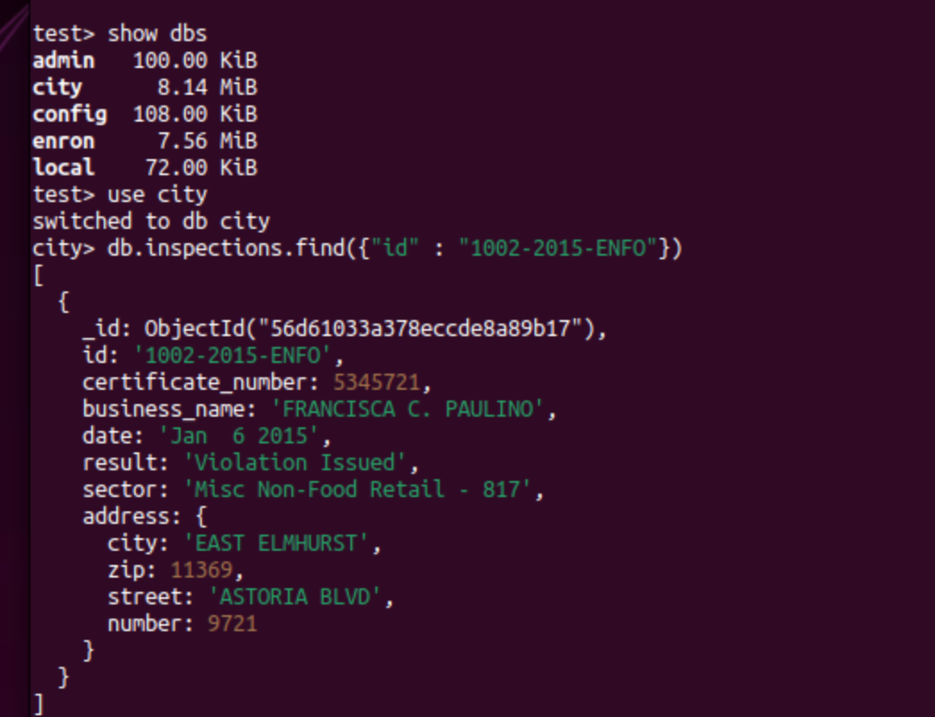

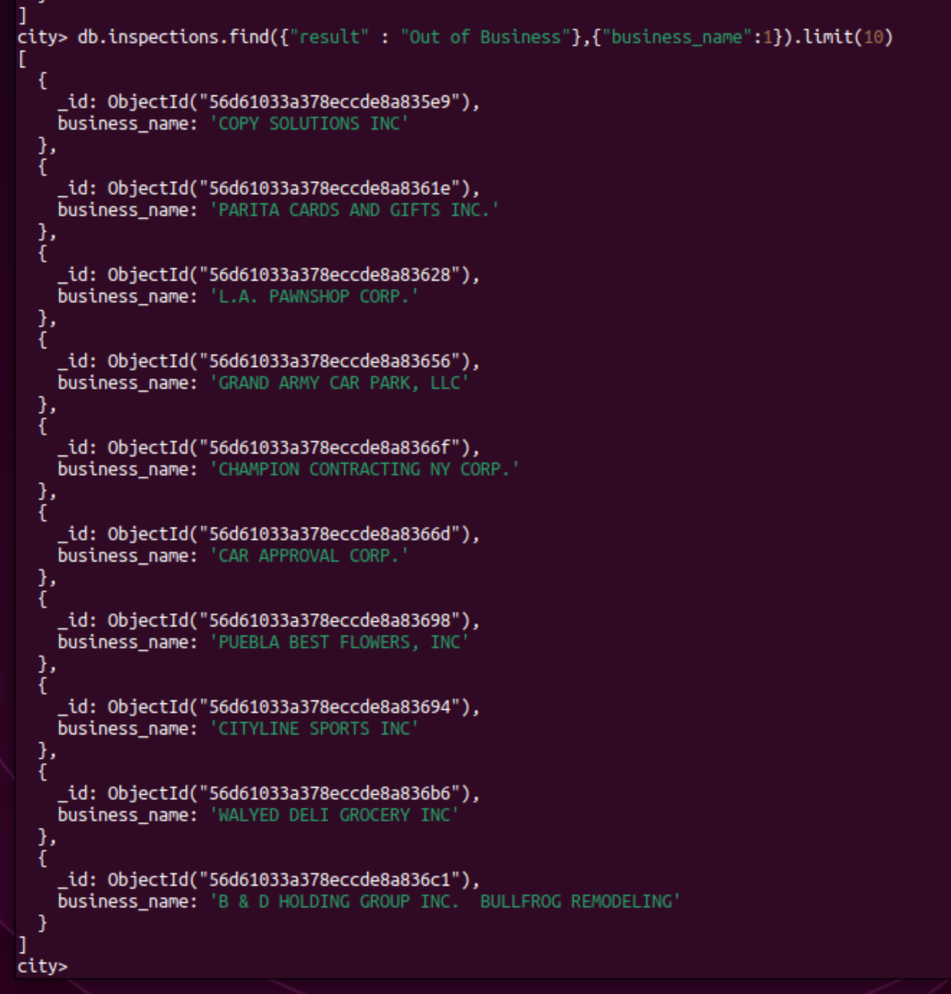

* **Document Insertion**
  1. The whole document will be a screen shot directly below to show the username, and then a zoomed screenshot showing the successful input code.

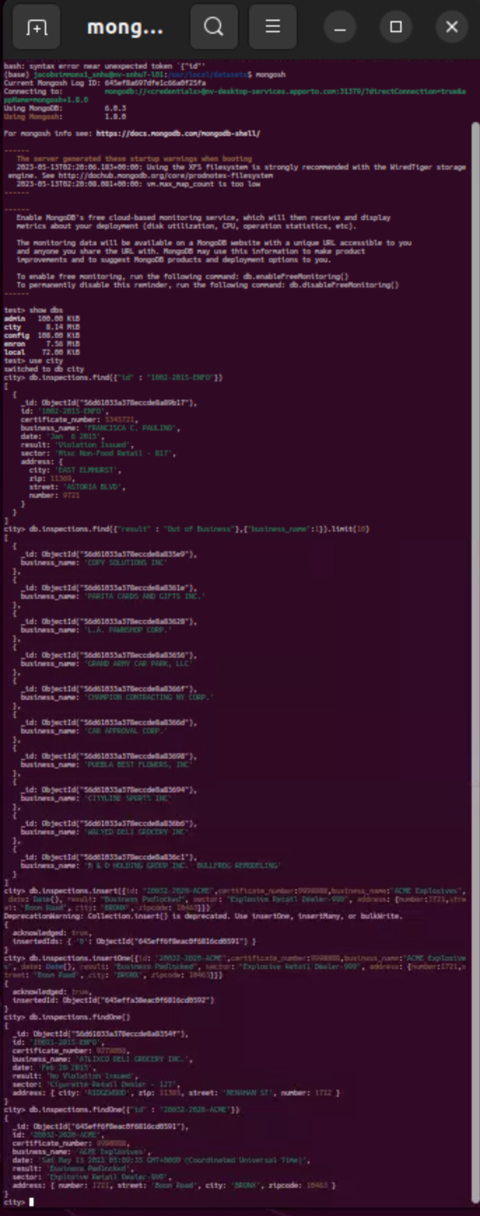

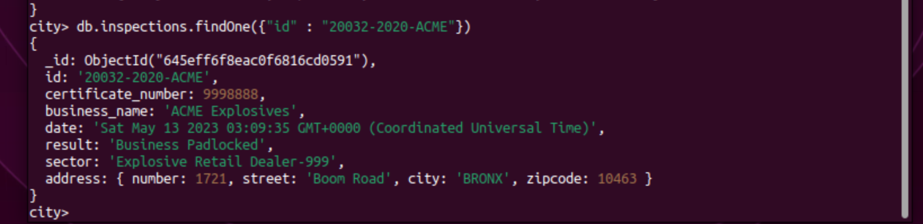

* Mongo Queries
  1. 87 unique values, distinct list is shown below

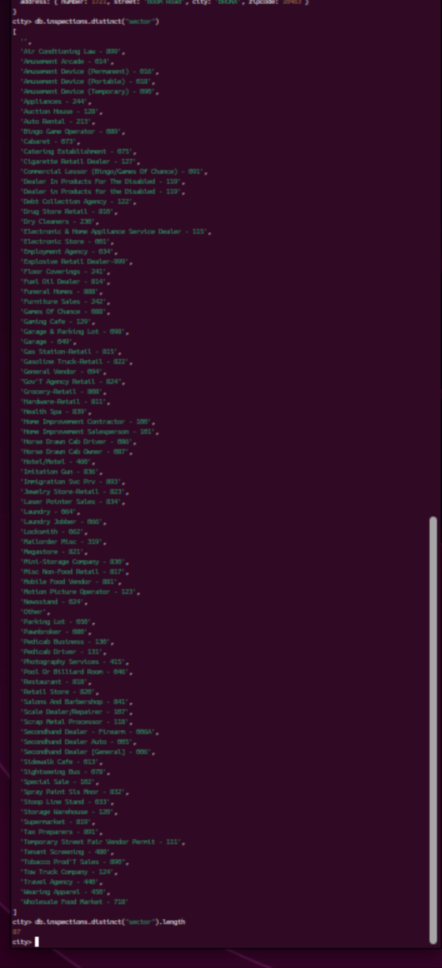

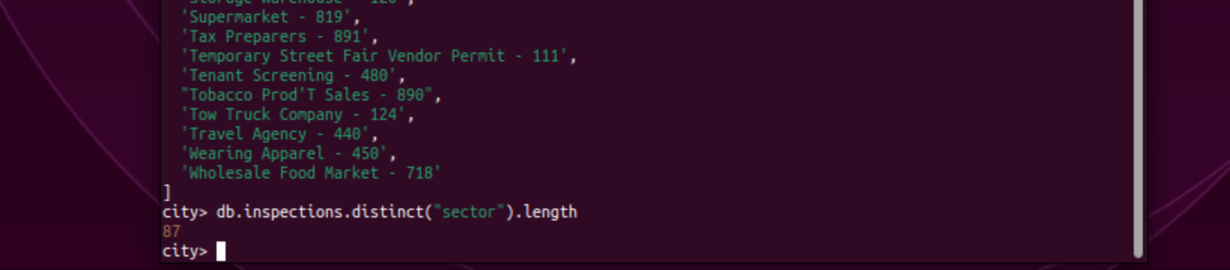

* 1. Find data types for date: date is the same

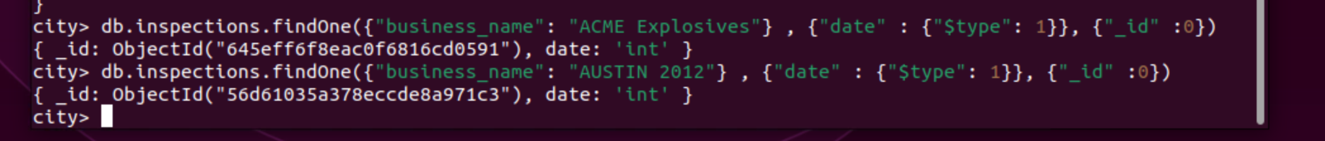

* 1. Violation Issued count:

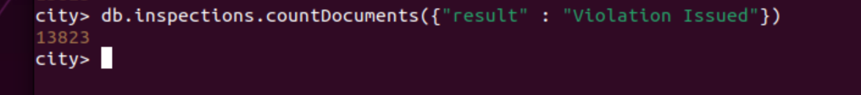

* **Update the document**

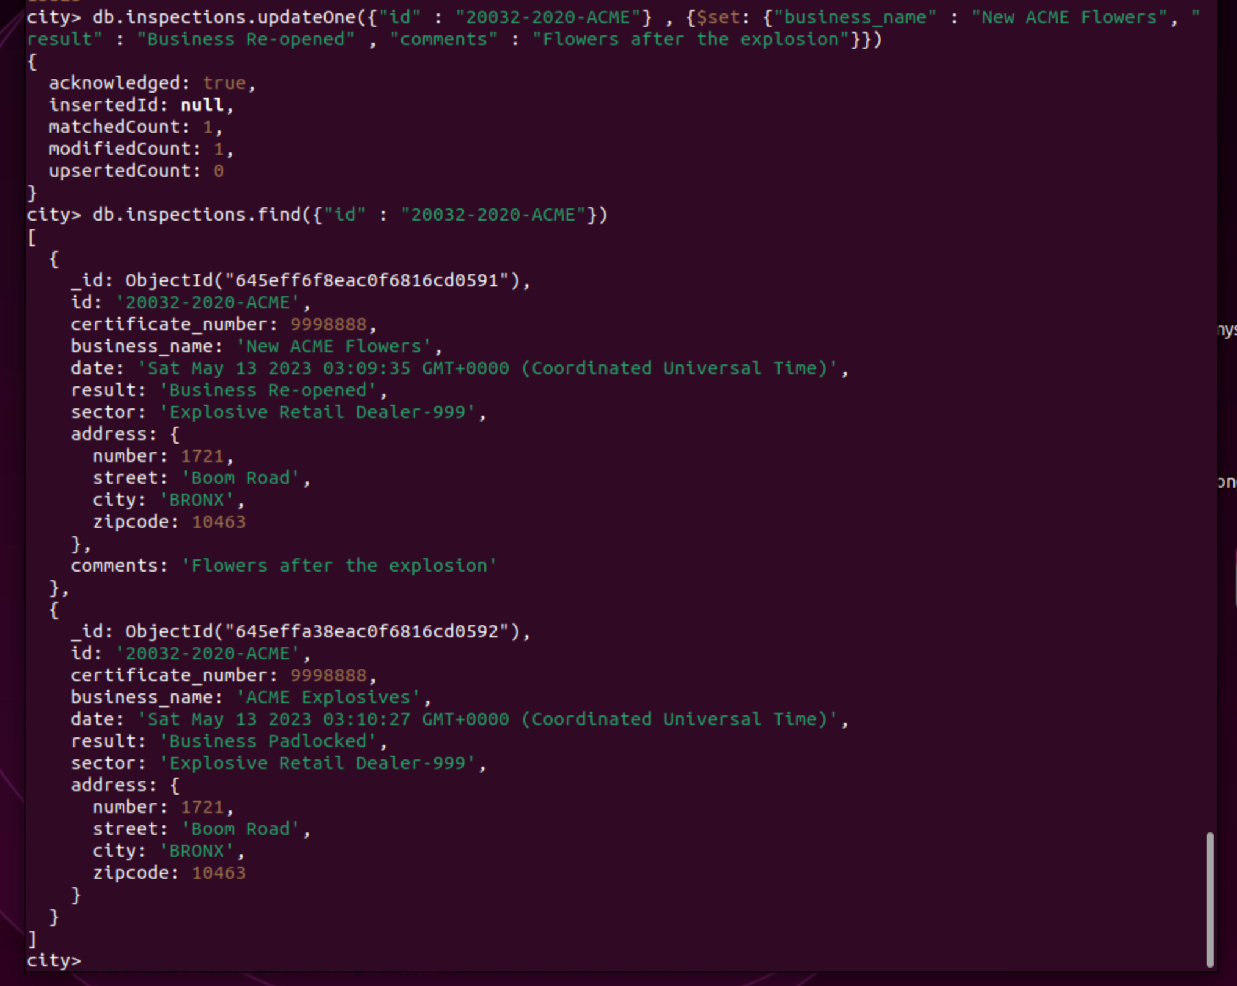

* **Updates zipcodes for ROSEDALE**

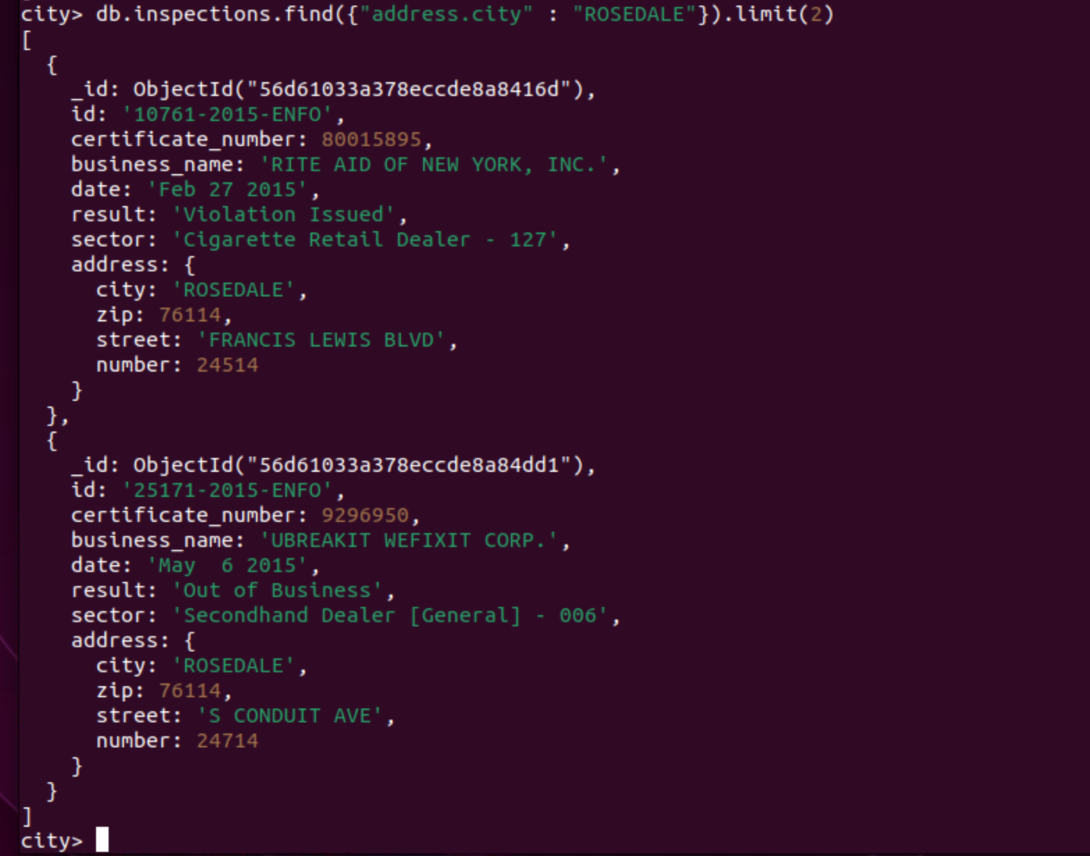

* **Delete first record with violation issued**

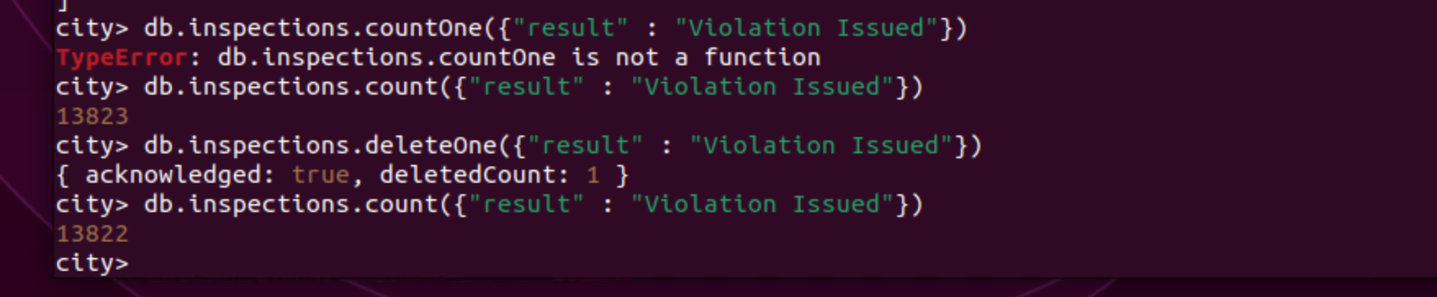

**Total Code Overview**

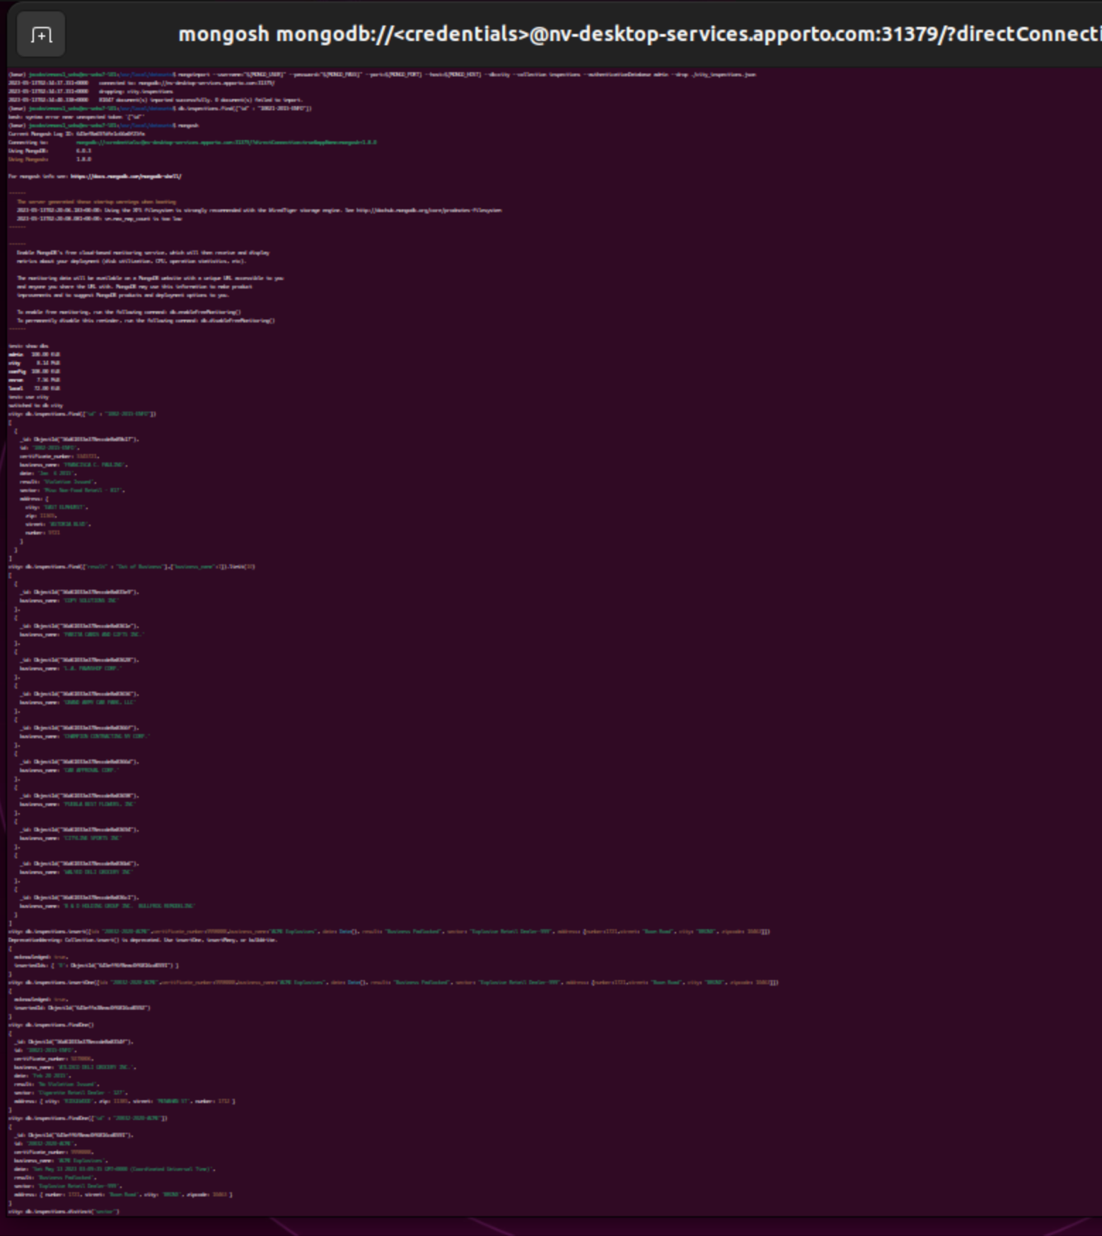

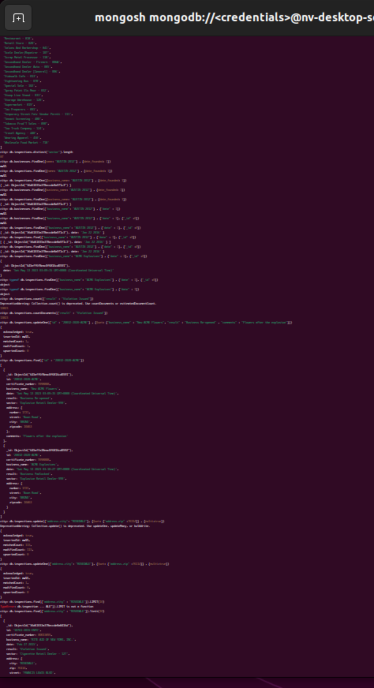

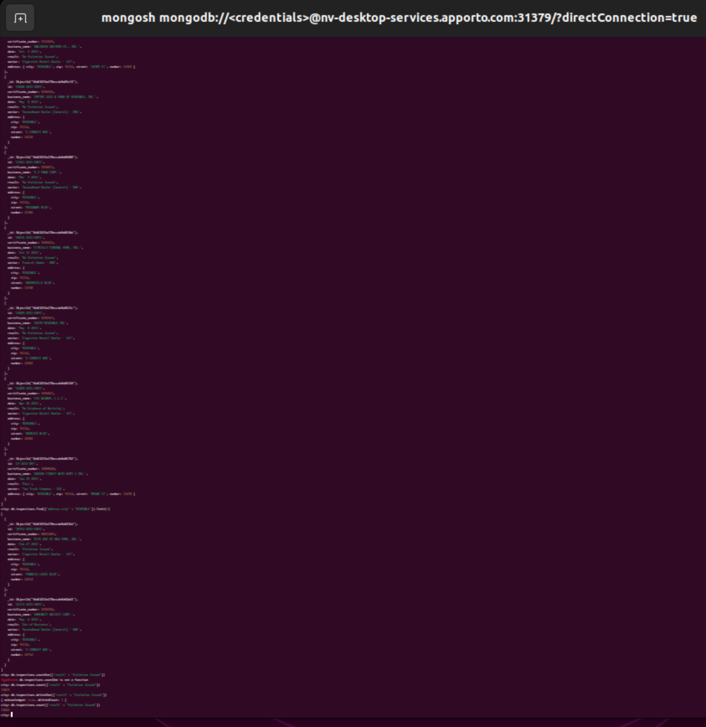

**References**

None